Support Our Sharks Club Affiliation
Dear Supporter,
As founder and director of the Support Our Sharks (SOS) Ocean Conservation Society, it is my goal to uphold the mission of SOS: to support healthy oceans by promoting better protection for sharks and rays. However, I can only do this with the help of hard working volunteers who dedicate their time and energy to support SOS campaigns and actions.
You can now get involved and make a positive contribution towards the protection of sharks worldwide by starting or joining an SOS affiliated club. As a member of an SOS affiliated club, you will be joining a network of over 100,000 people worldwide fighting for the protection of sharks. SOS affiliated clubs are encouraged to focus their time and resources on local issues affecting sharks in their region. Such activities may, for example, include developing educational programs for local schools, hosting community outreach events, and running local campaigns to reduce the consumption of sharks. Clubs are expected to work independently and are responsible for their own day-to-day running and management. Although SOS will keep a close eye on the activities of individual clubs, and will provide advice and resources where possible, it is ultimately the responsibility of the club officers to ensure that the club’s mission is being achieved.
At the request of club officers, SOS may assist with advertising club events through the SOS website and/or social media platforms. Clubs in good standing will be highlighted on the SOS website and in official SOS annual reports. Additionally, all affiliated club officers that have served at least 6 months on an affiliated club board may request that SOS act as a referee for job or college applications. Any references provided by SOS will be based on appropriate evidence presented to SOS regarding an individual member’s activities, as documented in the club’s quarterly reports.
For more information on how to start an SOS affiliated club and the requirements for acceptance, please download the SOS Club Affiliation Application. I look forward to welcoming you to our network of passionate shark supporters.
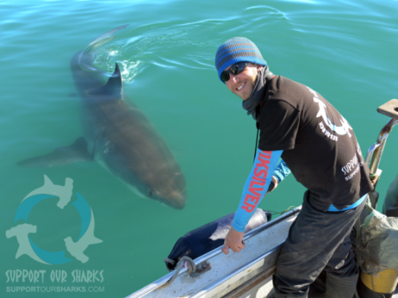
Sincerely,

Dr. Ryan Kempster
Shark Biologist and Founder of Support Our Sharks

www.supportoursharks.com
Pictured: Ryan Kempster
Benefits of Club Affiliation with Support Our Sharks
Benefit 1: Gain international exposure for club campaigns through the Support Our Sharks’ network.
Benefit 2: Gain international recognition for being a part of a trusted and respected conservation organisation.
Benefit 3: Reach over 100,000 people worldwide fighting for the protection of sharks through the SOS website, social media pages, and email list¹.
Benefit 4: Have your club officially recognised on the SOS website.
Benefit 5: Gain access to SOS resources (such as photos, videos, posters, etc.) for use in club activities².
Benefit 6: Gain direct access to SOS shark scientists for advice about campaigns.
Benefit 7: Have club activities officially recognised in the SOS Blog, SOS Annual Report, etc.²
Benefit 8: All club board members that have served at least 6 months may request a reference from SOS for college and job applications³.
Benefit 9: You will be helping us to achieve our mission to support healthy oceans by promoting better protection for sharks and rays.
¹Subject to approval by SOS, club activities may be shared via the SOS website, social media pages, and email list. ²Clubs may request use of SOS resources, but SOS will maintain the final decision as to whether any resources are provided. ³Any references provided by SOS will be based on documented evidence of a club members’ activities provided in quarterly reports to SOS.

How to Start a Support Our Sharks Affiliated Club
Step 1: Download an SOS Club Affiliation Application and ensure that you meet all the requirements and that you agree to the terms and conditions.
Step 2: Register your club within an academic institution that you are affiliated with.

Step 3: Establish a club board of at least 3 members, which must include, but is not limited to, a President (or equivalent), Vice-President (or equivalent), and Secretary (or equivalent).

Step 4: Find at least one academic member of staff from the institution where the club was registered (referred to in Step 2) to act as an advisor;

Step 5: Submit your application to SOS for your club to be recognised as an official SOS affiliated club (download the SOS Club Affiliation Application and submit to info@supportoursharks.com).

Step 6: Upon acceptance, your club will be officially recognised on the SOS website as an affiliated club, and SOS resources will be made available as per the guidelines in the SOS Club Affiliation Application.

Step 7: Clubs are encouraged to set up social media pages (such as Facebook) to be a source of information for their members.

