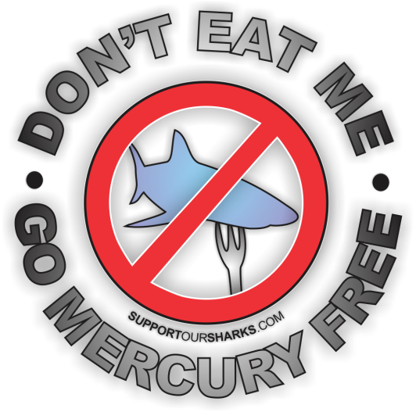
----------------------------------------------------------------------------------------------------------------------------
You may use this document as a template for your letter to encourage restaurant owners and supermarkets managers etc. to stop selling shark products due to the health risks associated with their consumption. Please remember to be polite in any correspondence.

- Find the contact details of your target.
- Fill out the missing information below.
- Edit this template as you require.
- Send/Email.

----------------------------------------------------------------------------------------------------------------------------

Dear [INSERT TARGET’S NAME HERE],

I am writing to you today to urge you to stop selling shark products, not only due to the negative effects that their removal has on ocean ecosystems¹, but also to the health risks associated with their consumption².

Sharks play a critical role in oceanic ecosystems in a way that the average fish does not³. Directly or indirectly, they regulate the natural balance of these ecosystems at all levels, and so are an integral part of them¹. As they usually hunt old, weak or sick prey, they help to keep the prey population in good condition, enabling the more naturally fit animals to reproduce and pass on their genes. The effects of removing sharks from ocean ecosystems, although complex, are very likely to be ecologically and economically damaging¹.

As many sharks are positioned at the top of the food chain, they are the final stop for many poisons in our oceans, such as mercury. As some shark species live for more than 50 years, the levels of mercury and other toxins that build up in their bodies are often much greater than in any other marine organisms⁴. Therefore, when we eat sharks, we also consume and accumulate these toxins and, for humans, the effects can be deadly⁴.

Organizations throughout the world, including the United States Environmental Protection Agency (USEPA), the World Health Organization (WHO) and the Food and Agriculture Organization of the United Nations (FAO), recognise mercury to be a dangerous neurotoxin and warn against eating sharks. Exposure to mercury can cause serious neurological disorders⁵, heart problems⁶, birth defects⁷, infertility⁸ and even death⁶. Studies have also found that some shark fins contain high-levels of BMAA, a dangerous neurotoxin linked to increased risk of Alzheimer’s and other degenerative brain diseases⁹.

Please help to maintain the health of our oceans and the public by ceasing the sale of all shark products.

Yours Sincerely,

[INSERT YOUR NAME AND CONTACT INFORMATION HERE]

